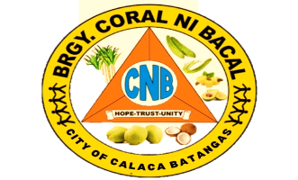**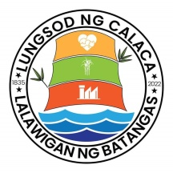 Republic of the Philippines**

**Province of Batangas**

**City of Calaca**

**BARANGAY CORAL NI BACAL**

**OFFICE OF THE SANGGUNIANG BARANGAY**

**BARANGAY CLEARANCE**

**BARANGAY CLEARANCE**

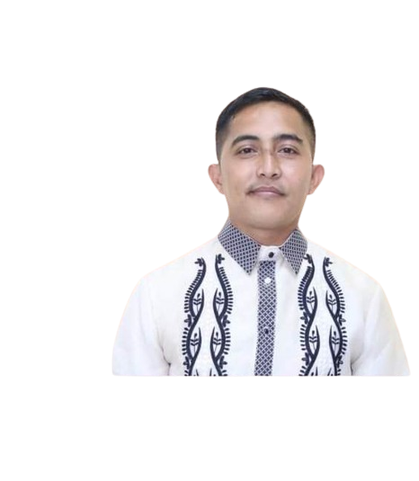 **CONTROL NO.: 42120430 OR NO.:** **DATE ISSUE.:** **TO WHOM IT MAY CONCERN, This to certify that , is a resident of Barangay Coral ni Bacal , Calaca City , Batangas has no derogatory in form as per record filed in this office. The above name person who is bonafide resident of this barangay is a person of good moral character , peaceful and law abiding citizen. This certification / clearance is hereby issued in connection with the subject’s application for and for whatever legal purposes it may serve him/her best. Respectfully your’s JOHN RYAN M. CABAÑEROS**  PUNONG BARANGAY  **SANGGUNIANG BARANGAY**

**HON. JOHN RYAN M. CABAÑEROS HON. KIAN JOHN FRANCIS E. CENTENO Punong Barangay SK Chairperson**

**NOTE: *Not Valid without official dry seal.***

**SANGGUNIANG BARANGAY MEMBER**

**HON. DANILO B. REYES**

**HON. ELINO P. PERALTA**

**HON. ROGER M. MALAPITAN**

**HON. JUN JUN B. DE MAYO**

**HON. AURORA P. MAGPANTAY**

**HON. PEDRO A. MENDOZA JR.**

**HON. MICHAEL C. ALCARAZ**

**DANMAR B. BESANA VANGELINE V. DIMAANO**

**Barangay Treasurer**

**Barangay Secretary**